**VISVESVARAYA TECHNOLOGICAL UNIVERSITY**

**“JnanaSangama”, Belgaum -590014, Karnataka.**



**LAB REPORT**

**On**

**ANALYSIS AND DESIGN OF ALGORITHMS (23CS4PCADA)**

**Submitted by**

**DYUTHI (1BM23CS097)**

**in partial fulfillment for the award of the degree of**

**BACHELOR OF ENGINEERING**

**in**

**COMPUTER SCIENCE AND ENGINEERING**



**B.M.S. COLLEGE OF ENGINEERING**

**(Autonomous Institution under VTU)**

**BENGALURU-560019**

**February-May 2025**

**B. M. S. College of Engineering,**

**Bull Temple Road, Bangalore 560019**

**(Affiliated To Visvesvaraya Technological University, Belgaum) Department of Computer Science and Engineering**



This is to certify that the Lab work entitled **“ANALYSIS AND DESIGN OF ALGORITHMS”** carried out by **DYUTHI(1BM23CS097)**, who is bonafide student of **B. M. S. College of Engineering**. It is in partial fulfillment for the award of **Bachelor of Engineering in Computer Science and Engineering** of the Visvesvaraya Technological University, Belgaum during the year 2024-25. The Lab report has been approved as it satisfies the academic requirements in respect of Analysis and Design of Algorithms Lab - **(23CS4PCADA)** work prescribed for the said degree.

|  |  |
| --- | --- |
| **SRUSTHI C S** | **Dr. Kavitha Sooda** |
| Assistant Professor | Professor and Head |
| Department of CSE | Department of CSE |
| BMSCE, Bengaluru | BMSCE, Bengaluru |

**Index Sheet**

|  |  |  |
| --- | --- | --- |
| **Sl.**  **No** | **Experiment Title** | **Page No.** |
| 1 | Write program to obtain the Topological ordering of vertices in a given digraph.      LeetCode Program related to Topological sorting | 5 |
| 2 | Sort a given set of N integer elements using Merge Sort technique and compute its time taken. Run the program for different values of N and record the time taken to sort.  LeetCode Program related to sorting. | 9 |
| 3 | Sort a given set of N integer elements using Quick Sort technique and compute its time taken.      LeetCode Program related to sorting. | 13 |
| 4 | Find Minimum Cost Spanning Tree of a given undirected graph using Prim’s algorithm.      Find Minimum Cost Spanning Tree of a given undirected graph using Kruskal’s algorithm. | 16 |
| 5 | From a given vertex in a weighted connected graph, find shortest paths to other vertices using Dijkstra’s algorithm. | 22 |
| 6 | Implement Johnson Trotter algorithm to generate permutations. | 25 |
| 7 | Implement Fractional Knapsack using Greedy technique.    LeetCode Program related to Greedy Technique algorithms. | 29 |
| 8 | Implement 0/1 Knapsack problem using dynamic programming.      LeetCode Program related to Knapsack problem or Dynamic Programming. | 32 |
| 9 | Sort a given set of N integer elements using Heap Sort technique and compute its time taken. | 36 |
| 10 | Implement All Pair Shortest paths problem using Floyd’s algorithm.  LeetCode Program related to shortest distance calculation. | 38 |
| 11 | Implement “N-Queens Problem” using Backtracking. | 41 |

**GITHUB LINK : https://github.com/Harsha6B/ADA Course Outcomes:**

|  |  |
| --- | --- |
| CO1 | Analyze time complexity of Recursive and Non-recursive algorithms using asymptotic notations. |
| CO2 | Apply various design techniques for the given problem. |
| CO3 | Apply the knowledge of complexity classes P, NP, and NP-Complete and prove certain problems are NP-Complete |
| CO4 | Design efficient algorithms and conduct practical experiments to solve problems. |

**Lab program 1.1:**

Write program to obtain the Topological ordering of vertices in a given digraph.

**Program full details**

**Code**

#include <stdio.h>

#include <stdbool.h>

#define MAX 100

int graph[MAX][MAX]; bool visited[MAX]; int stack[MAX]; int top = -1;

int n;

void push(int v) {

stack[++top] = v;

}

void dfs(int node) {

visited[node] = true; for (int i = 0; i < n; i++) {

if (graph[node][i] == 1 && !visited[i]) { dfs(i);

} } push(node);

}

void topologicalSort() {

for (int i = 0; i < n; i++) {

visited[i] = false;

}

for (int i = 0; i < n; i++) {

if (!visited[i]) {

dfs(i);

} }

printf("Topological Order: "); while (top != -1) {

printf("%d ", stack[top--]);

} printf("\n");

}

int main() {

printf("Enter number of vertices: "); scanf("%d", &n);

printf("Enter the adjacency matrix (0 or 1):\n"); for (int i = 0; i < n; i++) { for (int j = 0; j < n; j++) {

scanf("%d", &graph[i][j]);

} } topologicalSort(); return 0;

}

**Screenshot of Output**

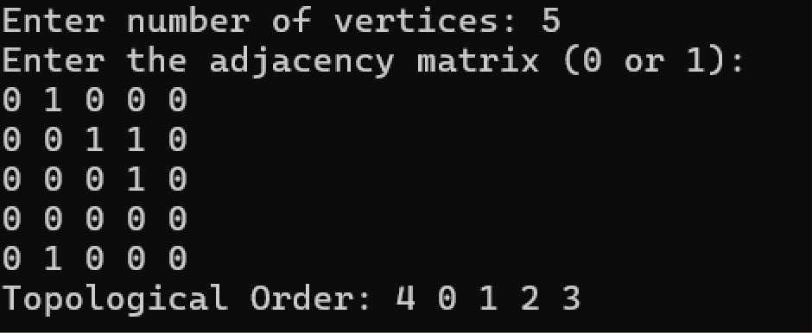

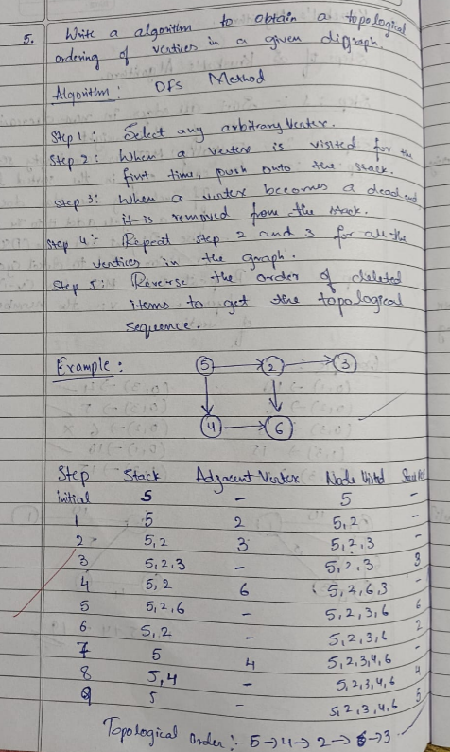

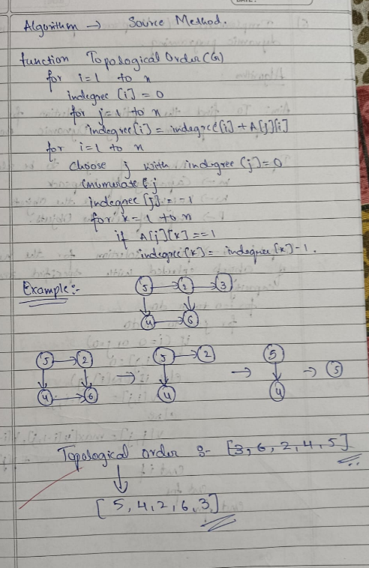

**Lab program 1.2:**

class Solution { public: bool canFinish(int numCourses, vector<vector<int>>& prerequisites) { vector<vector<int>> graph(numCourses); vector<int> indegree(numCourses, 0); for (const auto& pre : prerequisites) { graph[pre[1]].push_back(pre[0]); indegree[pre[0]]++;

}

queue<int> q;

for (int i = 0; i < numCourses; ++i) { if (indegree[i] == 0) q.push(i);

} int count = 0; while (!q.empty()) { int curr = q.front(); q.pop(); count++;

for (int next : graph[curr]) { indegree[next]--;

if (indegree[next] == 0) q.push(next);

}

}

return count == numCourses;

}

};

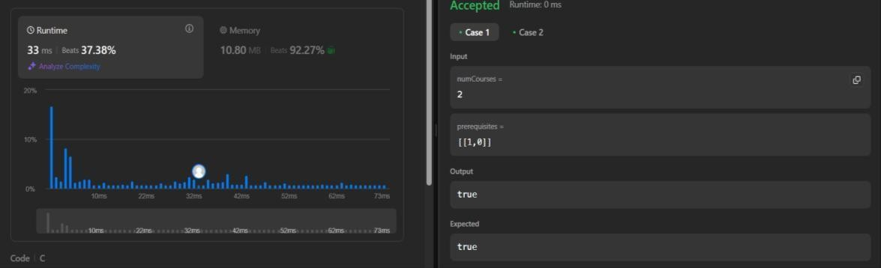

**Lab program 2:**

Sort a given set of N integer elements using Merge Sort technique and compute its time taken. Run the program for different values of N and record the time taken to sort.

**Code**

#include <stdio.h> #include <stdlib.h>

#include <time.h>

void merge(int arr[], int left, int right, int mid) { int i, j, k;

int n1 = mid - left + 1; int n2 = right - mid; int L[n1], R[n2];

for(i = 0; i < n1; i++) { L[i] = arr[left + i];

}

for(j = 0; j < n2; j++) {

R[j] = arr[mid + 1 + j];

}

i = 0; j = 0; k = left;

while(i < n1 && j < n2) {

if(L[i] <= R[j]) {

arr[k] = L[i]; i++;

} else { arr[k] = R[j]; j++; } k++;

}

while(i < n1) { arr[k] = L[i]; i++; k++;

}

while(j < n2) { arr[k] = R[j]; j++; k++;

}

}

void mergeSort(int arr[], int left, int right) {

if(left < right) {

int mid = left + (right - left) / 2; mergeSort(arr, left, mid); mergeSort(arr, mid + 1, right); merge(arr, left, right, mid);

}

}

void print(int arr[], int size) {

for(int i = 0; i < size; i++) {

printf("%d ", arr[i]);

} printf("\n");

}

int main() {

int n;

clock_t start, end;

printf("Enter the number of elements in the array: "); scanf("%d", &n);

int arr[n];

srand(time(NULL));

for(int i = 0; i < n; i++) { arr[i] = rand() % 1000;

}

printf("Original Array: "); print(arr, n);

start = clock();

mergeSort(arr, 0, n - 1);

end = clock();

printf("Sorted Array: "); print(arr, n);

printf("Time taken: %f seconds\n",1000* (double)(end - start) / CLOCKS_PER_SEC);

return 0;

}

**Screenshot of Output**

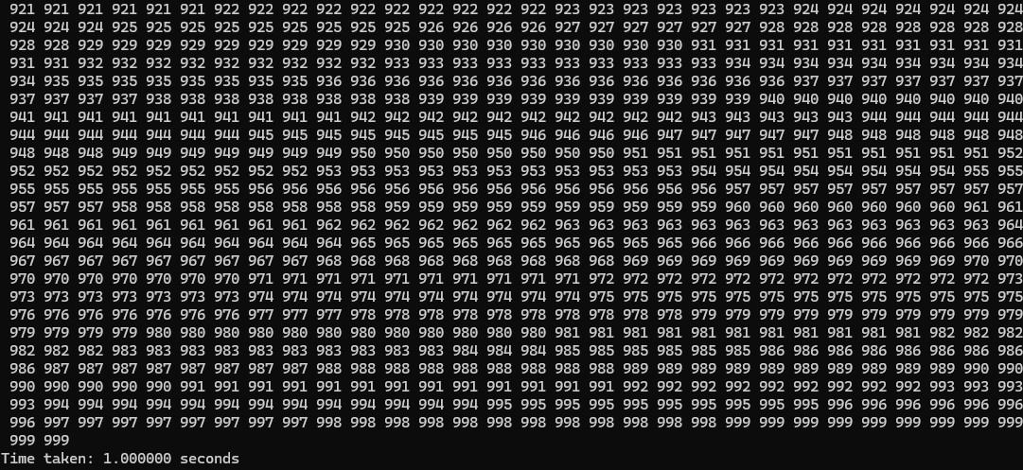

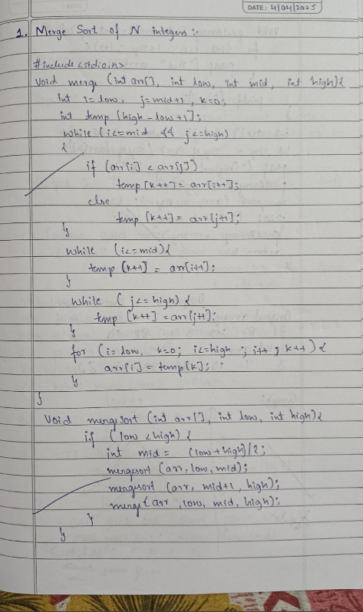

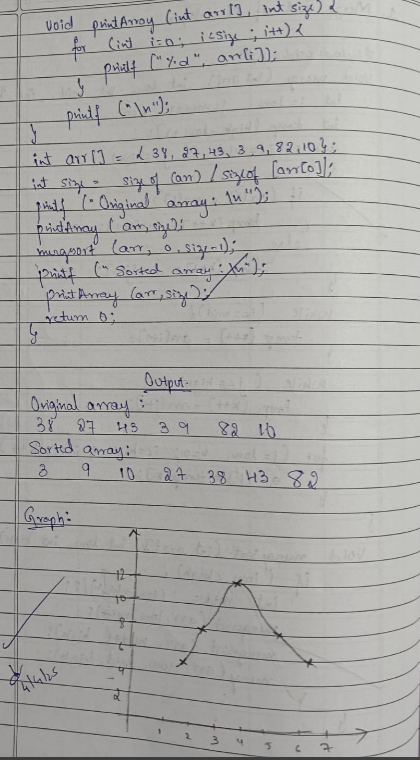

**Lab program 3:**

Sort a given set of N integer elements using Quick Sort technique and compute its time taken.

**Code**

#include <stdio.h> #include <stdlib.h>

#include <time.h>

int partition(int arr[], int low, int high) { int pivot = arr[high];

int i = low - 1;

for (int j = low; j <= high - 1; j++) { if (arr[j] < pivot) {

i++;

int temp = arr[i]; arr[i] = arr[j]; arr[j] = temp;

}

}

int temp = arr[i + 1]; arr[i + 1] = arr[high]; arr[high] = temp;

return (i + 1);

}

void quickSort(int arr[], int low, int high) {

if (low < high) {

int pi = partition(arr, low, high);

quickSort(arr, low, pi - 1); quickSort(arr, pi + 1, high);

}

}

void print(int arr[], int size) { for (int i = 0; i < size; i++) {

printf("%d ", arr[i]);

} printf("\n");

}

int main() {

int n;

clock_t start, end;

printf("Enter the number of elements in the array: "); scanf("%d", &n);

int arr[n];

srand(time(NULL));

for (int i = 0; i < n; i++) {

arr[i] = rand() % 1001;

}

printf("Original Array: "); print(arr, n);

start = clock();

quickSort(arr, 0, n - 1);

end = clock();

printf("Sorted Array: "); print(arr, n);

printf("Time taken: %f seconds\n",1000* (double)(end - start) / CLOCKS_PER_SEC);

return 0;

}

**Screenshot of Output**

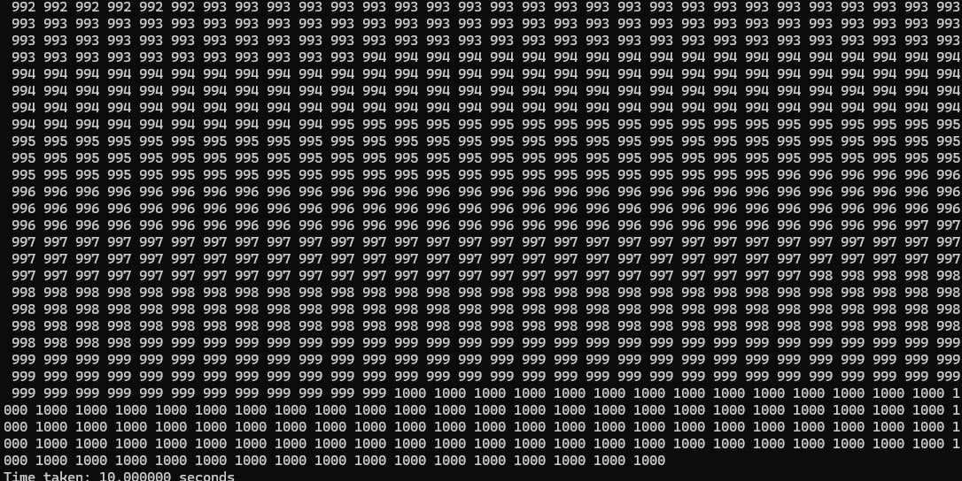

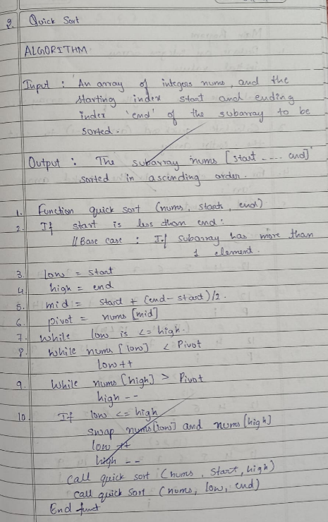

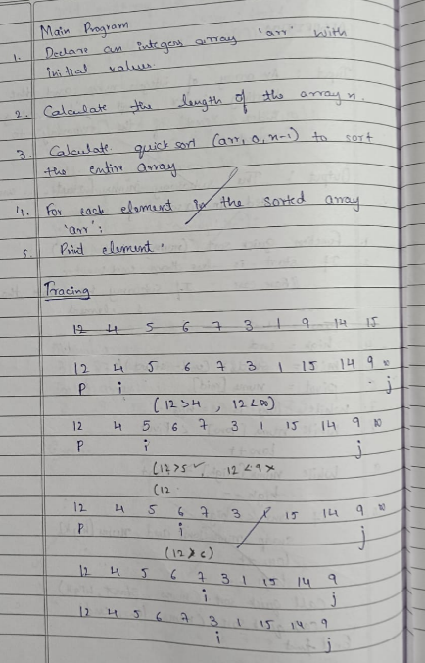

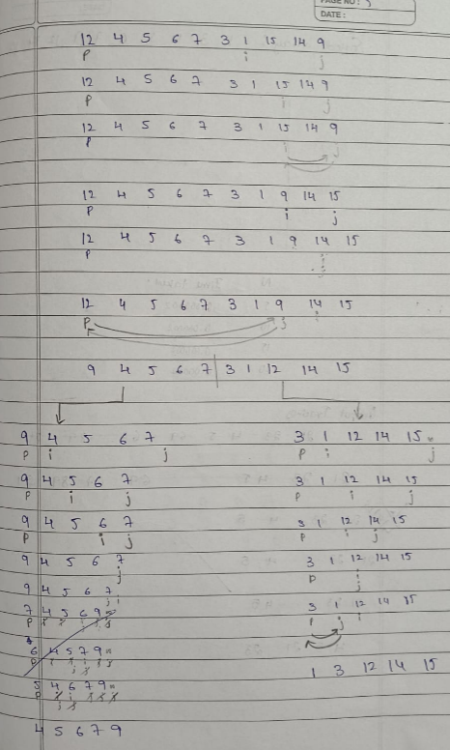

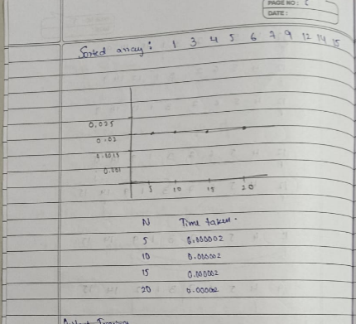

**Lab program 4:**

Find Minimum Cost Spanning Tree of a given undirected graph using Prim’s algorithm.

**Code**

#include<stdio.h

#include<conio.h>

int cost[10][10],vt[10],et[10][10],vis[10],j,n; int sum=0; int x=1; int e=0;

void prims();

void main()

{

int i;

printf("enter the number of vertices\n"); scanf("%d",&n); printf("enter the cost adjacency matrix\n"); for(i=1;i<=n;i++)

{ for(j=1;j<=n;j++)

{ scanf("%d",&cost[i][j]);

} vis[i]=0; } prims(); printf("edges of spanning tree\n"); for(i=1;i<=e;i++)

{ printf("%d,%d\t",et[i][0],et[i][1]);

}

printf("weight=%d\n",sum); getch();

}

void prims()

{ int s,min,m,k,u,v; vt[x]=1; vis[x]=1; for(s=1;s<n;s++)

{ j=x; min=999; while(j>0)

{ k=vt[j];

for(m=2;m<=n;m++)

{ if(vis[m]==0)

{ if(cost[k][m]<min)

j--;

} vt[++x]=v; et[s][0]=u; et[s][1]=v; e++; vis[v]=1;

sum=sum+min;

}

}

**Screenshot of Output**

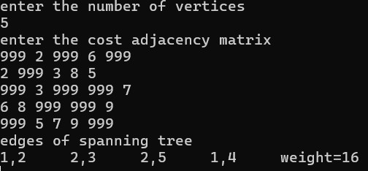

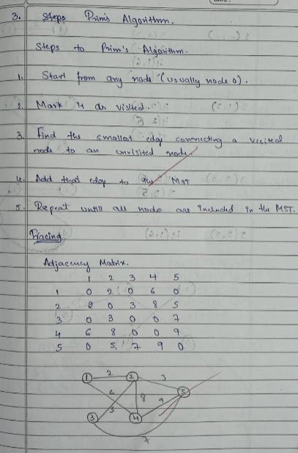

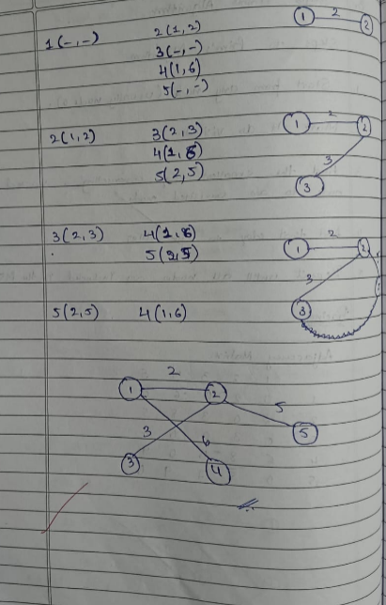

**Lab program 5:**

Find Minimum Cost Spanning Tree of a given undirected graph using Kruskal’s algorithm. **Code**

#include<stdio.h>

#include<conio.h>

int find(int v,int parent[10])

{ while(parent[v]!=v)

{ v=parent[v];

} return v;

}

void union1(int i,int j,int parent[10])

{ if(i<j) parent[j]=i;

else

parent[i]=j;

}

void kruskal(int n,int a[10][10])

{ int count,k,min,sum,i,j,t[10][10],u,v,parent[10]; count=0; k=0; sum=0; for(i=0;i<n;i++) parent[i]=i;

while(count!=n-1)

{ min=999; for(i=0;i<n;i++)

{ for(j=0;j<n;j++)

{

if(a[i][j]<min && a[i][j]!=0)

{ min=a[i][j]; u=i; v=j; .

}

} } i=find(u,parent); j=find(v,parent); if(i!=j)

{ union1(i,j,parent); t[k][0]=u; t[k][1]=v; k++; count++; sum=sum+a[u][v];

} a[u][v]=a[v][u]=999;

} if(count==n-1)

{ printf("spanning tree\n"); for(i=0;i<n-1;i++)

{ printf("%d %d\n",t[i][0],t[i][1]);

}

printf("cost of spanning tree=%d\n",sum);

} else printf("spanning tree does not exist\n");

}

void main()

{ int n,i,j,a[10][10]; clrscr(); printf("enter the number of nodes\n"); scanf("%d",&n); printf("enter the adjacency matrix\n"); for(i=0;i<n;i++)

for(j=0;j<n;j++) scanf("%d",&a[i][j]);

kruskal(n,a); getch();

}

**Screenshot of Output**

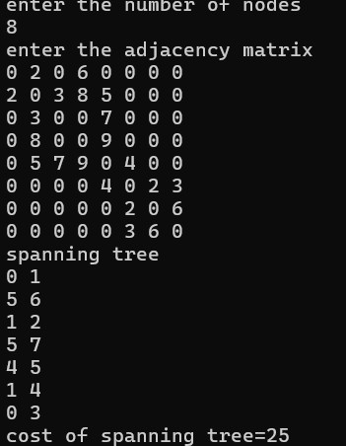

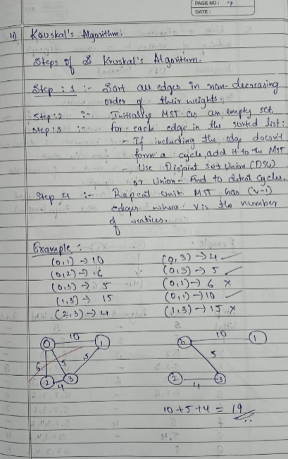

**Lab program 6:**

From a given vertex in a weighted connected graph, find shortest paths to other vertices using Dijkstra’s algorithm.

**Code**

#include <stdio.h>

#define INF 999

void dijkstra(int n, int cost[10][10], int src) {

int i, j, u, dis[10], vis[10], min;

// Initialize distances and visited flags for (i = 1; i <= n; i++) {

dis[i] = cost[src][i]; vis[i] = 0;

}

vis[src] = 1;

for (i = 1; i < n; i++) {

min = INF;

u = -1;

// Find the unvisited vertex with the smallest distance for (j = 1; j <= n; j++) {

if (vis[j] == 0 && dis[j] < min) {

min = dis[j]; u = j;

}

}

if (u == -1) break; // All reachable vertices visited

vis[u] = 1;

// Update distances to neighboring vertices for (j = 1; j <= n; j++) {

if (vis[j] == 0 && dis[u] + cost[u][j] < dis[j]) {

dis[j] = dis[u] + cost[u][j];

}

}

}

printf("Shortest paths from vertex %d:\n", src); for (i = 1; i <= n; i++) {

if (dis[i] == INF)

printf("%d -> %d = INF\n", src, i);

else

printf("%d -> %d = %d\n", src, i, dis[i]); }

}

int main() {

int src, j, cost[10][10], n, i;

printf("Enter the number of vertices: "); scanf("%d", &n);

printf("Enter the cost adjacency matrix (use 999 for no connection):\n"); for (i = 1; i <= n; i++) {

for (j = 1; j <= n; j++) {

scanf("%d", &cost[i][j]);

}

}

printf("Enter the source vertex: "); scanf("%d", &src);

dijkstra(n, cost, src);

return 0;

}

**Screenshot of Output**

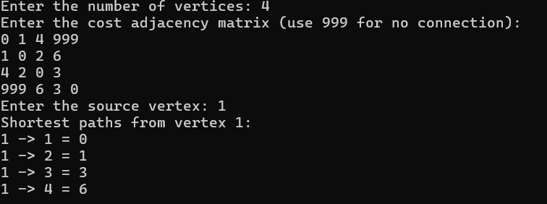

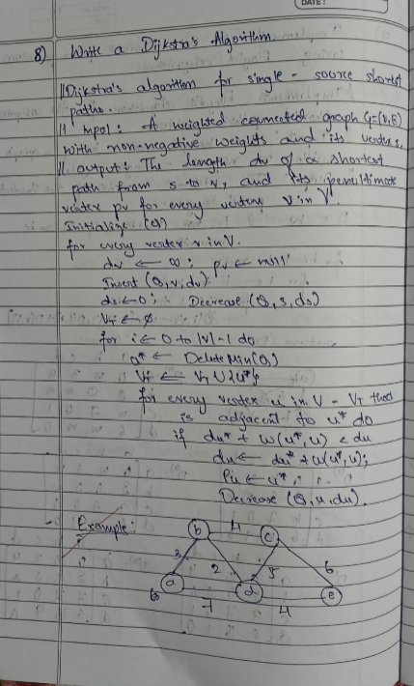

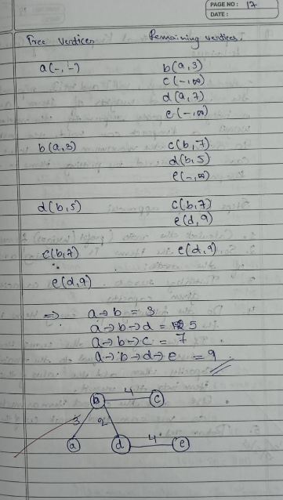

**Lab program 7:**

Implement Johnson Trotter algorithm to generate permutations.

**Code**

#include <stdio.h>

#define LEFT_TO_RIGHT 1

#define RIGHT_TO_LEFT 0

int searchArr(int a[], int n, int mobile) {

for (int i = 0; i < n; i++)

if (a[i] == mobile)

return i + 1;

return -1;

}

int getMobile(int a[], int dir[], int n) {

int mobile_prev = 0, mobile = 0;

for (int i = 0; i < n; i++) {

if (dir[a[i] - 1] == RIGHT_TO_LEFT && i != 0) {

if (a[i] > a[i - 1] && a[i] > mobile_prev) {

mobile = a[i]; mobile_prev = mobile;

} }

if (dir[a[i] - 1] == LEFT_TO_RIGHT && i != n - 1) {

if (a[i] > a[i + 1] && a[i] > mobile_prev) {

mobile = a[i]; mobile_prev = mobile;

}

}

}

return mobile;

}

void printOnePerm(int a[], int dir[], int n) {

int mobile = getMobile(a, dir, n); int pos = searchArr(a, n, mobile);

if (mobile == 0) return;

if (dir[a[pos - 1] - 1] == RIGHT_TO_LEFT) {

int temp = a[pos - 1]; a[pos - 1] = a[pos - 2]; a[pos - 2] = temp;

} else if (dir[a[pos - 1] - 1] == LEFT_TO_RIGHT) { int temp = a[pos]; a[pos] = a[pos - 1]; a[pos - 1] = temp;

}

for (int i = 0; i < n; i++) {

if (a[i] > mobile) {

dir[a[i] - 1] = !dir[a[i] - 1]; // toggle direction

}

}

for (int i = 0; i < n; i++)

printf("%d", a[i]);

printf(" ");

}

int fact(int n) {

int res = 1; for (int i = 1; i <= n; i++) res = res * i;

return res;

}

void printPermutation(int n) {

int a[n], dir[n];

for (int i = 0; i < n; i++) { a[i] = i + 1; printf("%d", a[i]); }

printf("\n");

for (int i = 0; i < n; i++)

dir[i] = RIGHT_TO_LEFT;

for (int i = 1; i < fact(n); i++)

printOnePerm(a, dir, n);

}

int main() { int n = 4; printPermutation(n); return 0;

}

**Screenshot of Output**



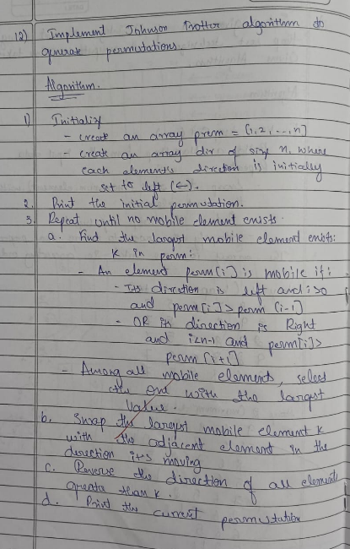

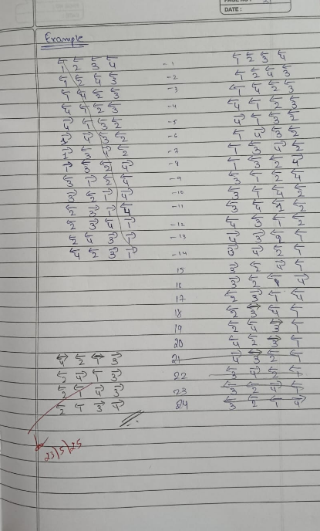

**Lab program 8.1:**

Implement Fractional Knapsack using Greedy technique.

**Code**

#include <stdio.h>

int main() {

float weight[50], profit[50], ratio[50]; float Totalvalue = 0.0, temp, capacity, amount;

int n, i, j;

printf("Enter the number of items: "); scanf("%d", &n);

for (i = 0; i < n; i++) {

printf("Enter Weight and Profit for item[%d]:\n", i); scanf("%f %f", &weight[i], &profit[i]);

}

printf("Enter the capacity of knapsack:\n"); scanf("%f", &capacity);

// Calculate profit/weight ratio for (i = 0; i < n; i++)

ratio[i] = profit[i] / weight[i];

// Sort items by descending ratio for (i = 0; i < n; i++) {

for (j = i + 1; j < n; j++) { if (ratio[i] < ratio[j]) {

// Swap ratio temp = ratio[i]; ratio[i] = ratio[j]; ratio[j] = temp;

// Swap weight temp = weight[i]; weight[i] = weight[j]; weight[j] = temp;

// Swap profit temp = profit[i]; profit[i] = profit[j]; profit[j] = temp;

}

}

}

printf("\nKnapsack problem using Greedy Algorithm:\n"); for (i = 0; i < n; i++) { if (weight[i] <= capacity) { // Take full item

printf("Item[%d] taken completely (100%%)\n", i); Totalvalue += profit[i]; capacity -= weight[i];

} else {

// Take fraction of item float fraction = capacity / weight[i]; Totalvalue += profit[i] * fraction; printf("Item[%d] taken partially (%.2f%%)\n", i, fraction * 100); break; // Knapsack is now full

}

}

printf("\nThe maximum value is: %.2f\n", Totalvalue); return 0;

}

**Screenshot of Output**

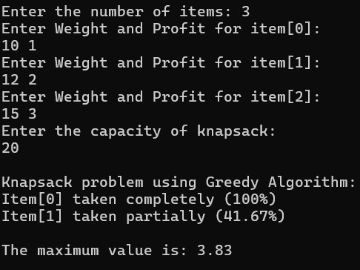

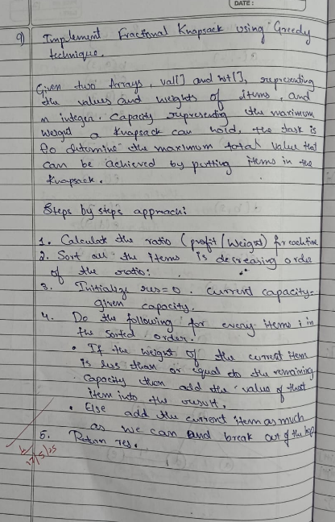

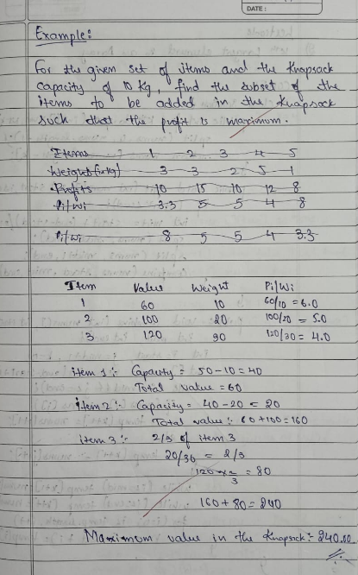

**Lab program 8.2:**

LeetCode Program related to Greedy Technique algorithms

**Code**

char* largestOddNumber(char* num) {

int len = strlen(num);

for (int i = len - 1; i >= 0; i--) { if ((num[i] - '0') % 2 == 1) { num[i + 1] = '\0'; // Truncate string at that position return num; // Return the longest odd-suffix (greedy)

}

}

return ""; // No odd digit found

}

**Screenshot of Output**

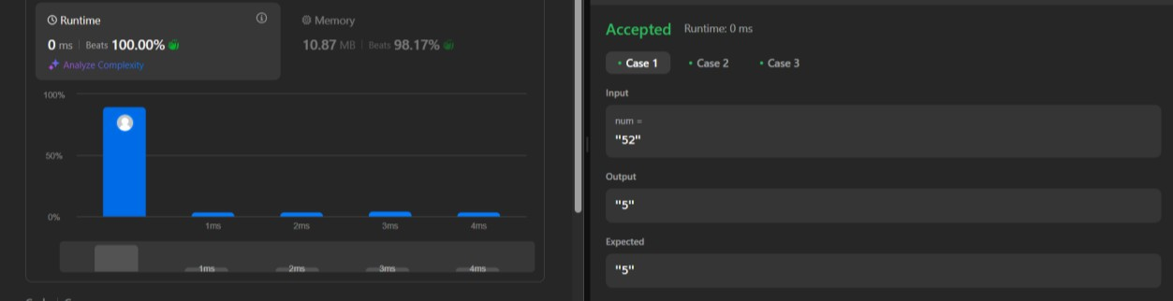

**Lab program 9.1:**

Implement 0/1 Knapsack problem using dynamic programming.

**Code**

#include <stdio.h>

// Function to return the maximum of two numbers int max(int a, int b) {

return (a > b) ? a : b;

}

// Function to solve the 0/1 Knapsack problem

int knapsack(int weight[], int profit[], int n, int capacity) { int i, w;

int K[n + 1][capacity + 1];

// Build the DP table K[][] bottom up for (i = 0; i <= n; i++) { for (w = 0; w <= capacity; w++) { if (i == 0 || w == 0)

K[i][w] = 0; else if (weight[i - 1] <= w)

K[i][w] = max(profit[i - 1] + K[i - 1][w - weight[i - 1]], K[i - 1][w]); else

K[i][w] = K[i - 1][w];

}

}

// Optional: Print the items included printf("\nItems included:\n"); w = capacity;

for (i = n; i > 0 && w > 0; i--) { if (K[i][w] != K[i - 1][w]) { printf("Item %d (Weight: %d, Profit: %d)\n", i, weight[i - 1], profit[i - 1]); w -= weight[i - 1];

}

}

return K[n][capacity];

}

int main() {

int n, capacity; int weight[50], profit[50]; int i;

printf("Enter number of items: "); scanf("%d", &n);

printf("Enter weight and profit for each item:\n"); for (i = 0; i < n; i++) {

printf("Item[%d] - Weight Profit: ", i + 1); scanf("%d %d", &weight[i], &profit[i]);

}

printf("Enter the capacity of knapsack: "); scanf("%d", &capacity);

int maxProfit = knapsack(weight, profit, n, capacity);

printf("\nMaximum profit: %d\n", maxProfit); return 0;

}

**Screenshot of Output**

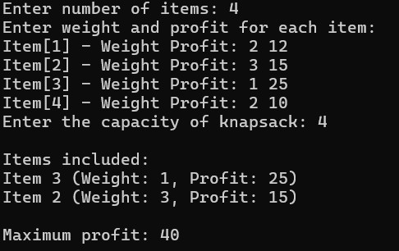

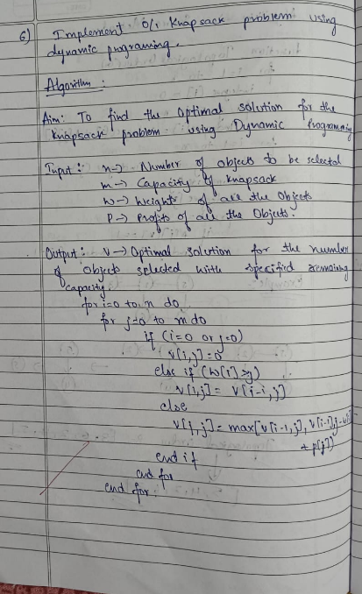

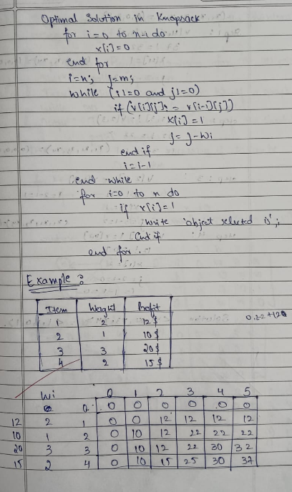

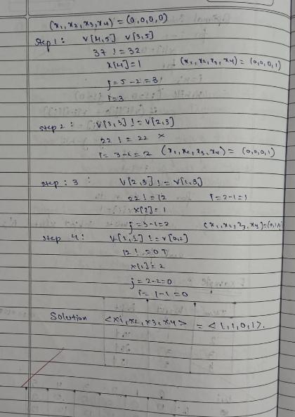

**Lab program 9.2:**

**Code**

class Solution(object):

def fib(self, n):

if n == 0: return 0

if n == 1: return 1

a, b = 0, 1 for _ in range(2, n + 1): a, b = b, a + b

return b

**Screenshot of Output**

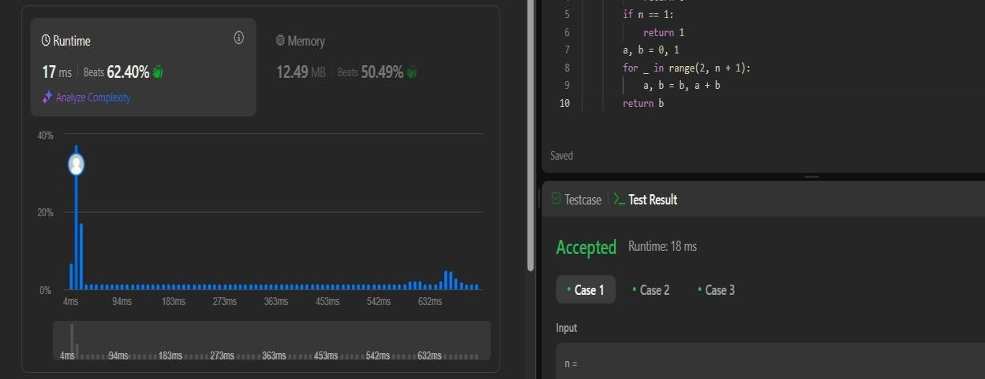

**Lab program 10:**

Sort a given set of N integer elements using Heap Sort technique and compute its time taken

**Code**

#include <stdio.h>

#include <time.h>

void heapify(int arr[], int n, int i) { int largest = i; int left = 2 * i + 1; int right = 2 * i + 2;

if (left < n && arr[left] > arr[largest]) largest = left;

if (right < n && arr[right] > arr[largest]) largest = right;

if (largest != i) { int temp = arr[i]; arr[i] = arr[largest]; arr[largest] = temp;

heapify(arr, n, largest);

}

}

void heapSort(int arr[], int n) { for (int i = n / 2 - 1; i >= 0; i--) heapify(arr, n, i);

for (int i = n - 1; i >= 0; i--) { int temp = arr[0]; arr[0] = arr[i]; arr[i] = temp;

heapify(arr, i, 0);

} }

int main() {

int arr[1000], n; clock_t start, end;

double time_taken;

printf("Enter number of elements: ");

scanf("%d", &n);

printf("Enter %d integer elements:\n", n);

for (int i = 0; i < n; i++) scanf("%d", &arr[i]); start = clock(); heapSort(arr, n);

end = clock();

time_taken = ((double)(end - start)) / CLOCKS_PER_SEC;

printf("\nSorted array is:\n"); for (int i = 0; i < n; i++)

printf("%d ", arr[i]);

printf("\n\nTime taken by Heap Sort: %f seconds\n", time_taken);

return 0;

}

**Screenshot of Output**

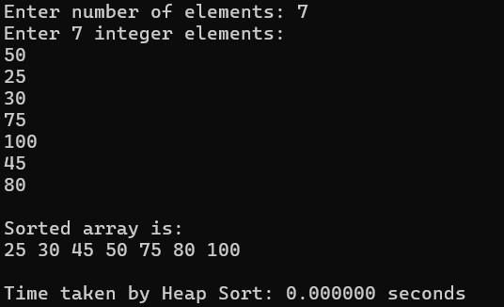

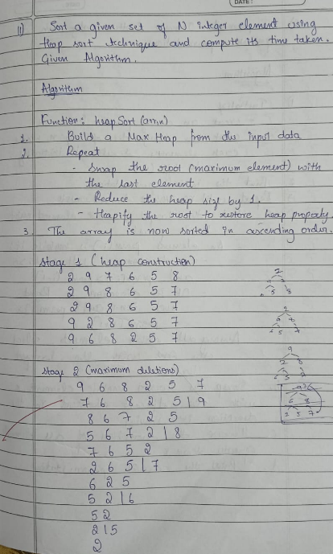

**Lab program 11.1:**

Implement All Pair Shortest paths problem using Floyd’s algorithm.

**Code**

#include <stdio.h>

#define INF 99999 // Use a large number to represent infinity

#define MAX 100

void floydWarshall(int graph[MAX][MAX], int n) {

int dist[MAX][MAX];

int i, j, k;

// Initialize the solution matrix same as input graph for (i = 0; i < n; i++)

for (j = 0; j < n; j++)

dist[i][j] = graph[i][j];

// Floyd-Warshall algorithm for (k = 0; k < n; k++) {

for (i = 0; i < n; i++) {

for (j = 0; j < n; j++) {

if (dist[i][k] + dist[k][j] < dist[i][j])

dist[i][j] = dist[i][k] + dist[k][j];

}

}

}

// Print the final shortest distance matrix

printf("\nAll-Pairs Shortest Paths (Floyd-Warshall):\n"); for (i = 0; i < n; i++) {

for (j = 0; j < n; j++) {

if (dist[i][j] == INF)

printf("INF ");

else

printf("%3d ", dist[i][j]);

} printf("\n");

}

}

int main() {

int graph[MAX][MAX], n;

printf("Enter number of vertices: "); scanf("%d", &n);

printf("Enter the adjacency matrix (use 99999 for no direct path):\n"); for (int i = 0; i < n; i++) {

for (int j = 0; j < n; j++) {

scanf("%d", &graph[i][j]);

}

}

floydWarshall(graph, n);

return 0;

}

**Screenshot of Output**

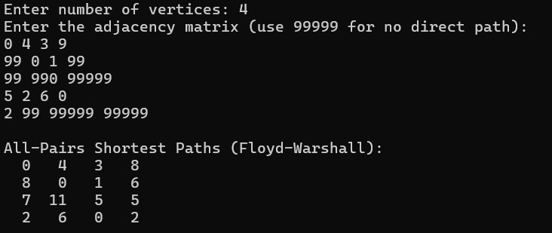

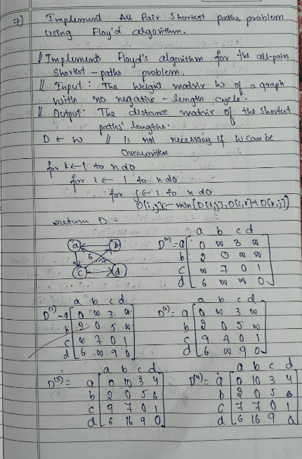

**Lab program 11.2:**

LeetCode Program related to shortest distance calculation

**Code**

class Solution:

def shortestPathLength(self, graph: List[List[int]]) -> int:

n=len(graph)

queue=deque([(i,1<<i) for i in range(n)]) seen=set(queue) ans=0 while queue:

for _ in range(len(queue)): u,m=queue.popleft() if m==(1<<n)-1:

return ans

for v in graph[u]:

if (v,m|1<<v) not in seen: queue.append((v,m|1<<v)) seen.add((v,m|1<<v))

ans+=1

**Screenshot of Output**

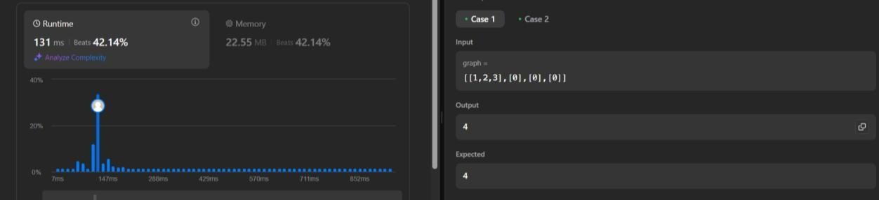

**Lab program 12:**

Implement “N-Queens Problem” using Backtracking.

**Code**

#include <stdio.h>

#include <math.h>

#define MAX 20

int board[MAX]; int found = 0;

// Function to print one solution void printSolution(int n) { printf("One solution for %d-Queens:\n", n); for (int i = 1; i <= n; i++) { for (int j = 1; j <= n; j++) { if (board[i] == j) printf("Q "); else

printf(". "); } printf("\n"); } found = 1;

}

// Check if placing queen at (k, i) is safe int isSafe(int k, int i) {

for (int j = 1; j < k; j++) {

if (board[j] == i || fabs(board[j] - i) == fabs(j - k))

return 0; } return 1;

}

// Recursive backtracking to find one solution void nQueens(int k, int n) {

for (int i = 1; i <= n && !found; i++) {

if (isSafe(k, i)) {

board[k] = i; if (k == n)

printSolution(n);

else

nQueens(k + 1, n);

}

} }

int main() {

int n;

printf("Enter number of queens (N): "); scanf("%d", &n);

if (n < 1 || n > MAX) {

printf("Please enter N between 1 and %d.\n", MAX); return 1;

}

nQueens(1, n);

if (!found)

printf("No solution exists for N = %d\n", n);

return 0;

}

**Screenshot of Output**

